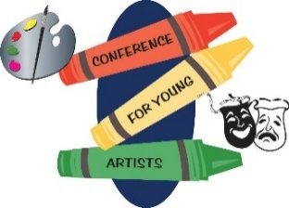
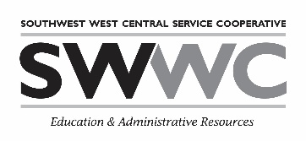
Conference for Young Artists
1420 E. College Drive
Marshall, MN 56258
October 25, 2023
Student/Adult Survey

- Select One
Student Adult
- What grade are you in? (Students select One)
K 1 2 3 4 5 6 7 8

- Rate the Keynote Presentation
Excellent Good Average Fair
What did you learn during the Keynote Presentation?

- Did you explore and learn something new at the conference?
Yes, for sure Kind of Not so much

- List the three sessions you took (by letter or title):

- What was your favorite session and what was fun about it?

- What art techniques did you learn?

- Would you attend Young Artists again?
Yes No Maybe

- Adult: How has this experience influenced your child/student(s)?

- Comments about the conference:

- Suggestions for future topics, speakers, etc.

